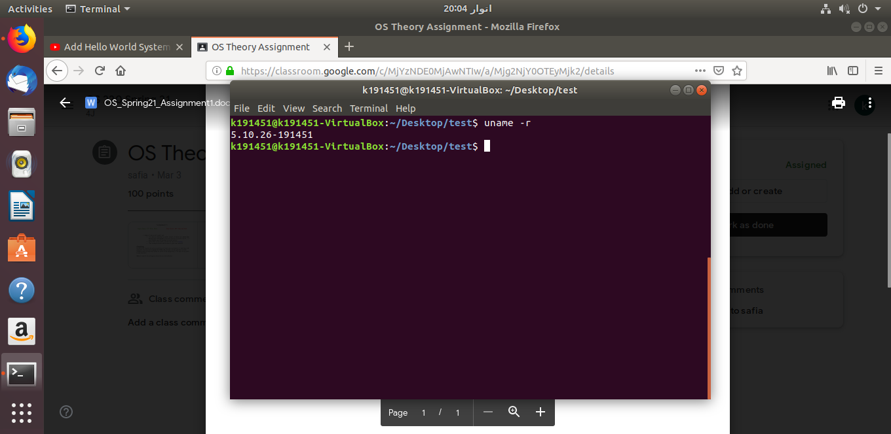
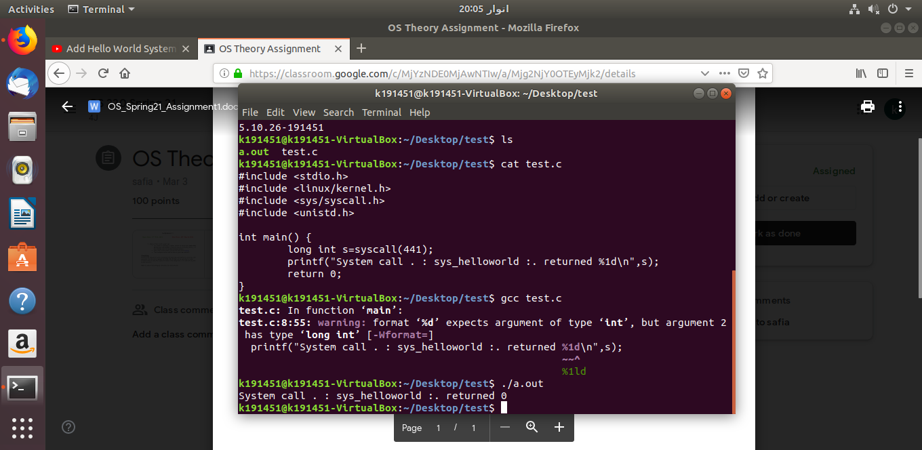
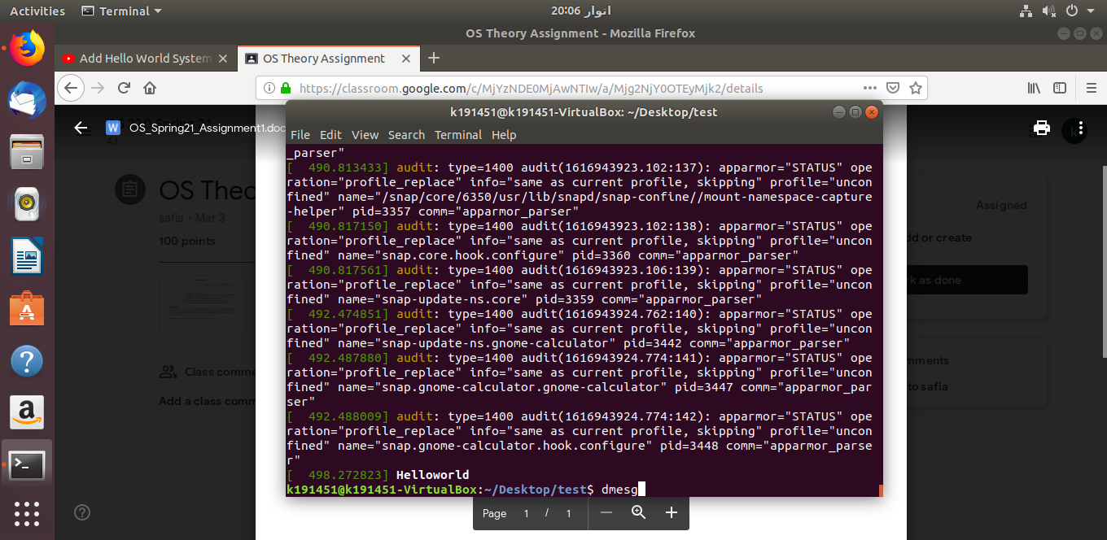
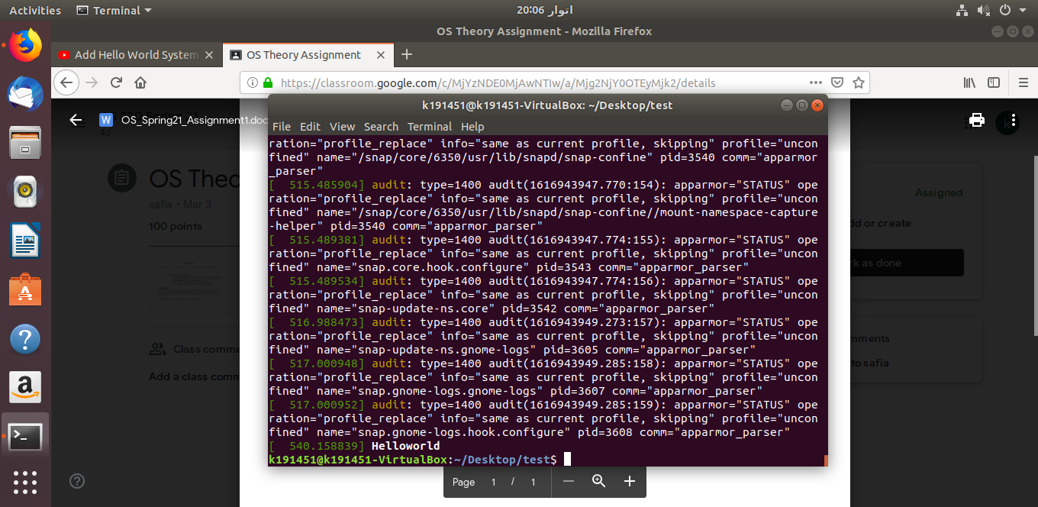

Procedure:
- sudo apt-get update
- sudo apt-get install libncurses-dev flex bison openssl libssl-dev dkms libelf-dev libudev-dev libpci-dev libiberty-dev autoconf
- sudo add-apt-repository "deb http://archive.ubuntu.com/ubuntu $(lsb_release -sc) main universe"
- sudo -i
- mkdir /kernels
- cd /kernels
- wget https://cdn.kernel.org/pub/linux/kernel/v5.x/linux-5.10.26.tar.xz
- tar xf linux-5.10.26.tar.xz
- mv linux-5.10.26 /usr/src/
- cd /usr/src/linux-5.10.26
- mkdir helloworld
- cd helloworld
- gedit helloworld.c
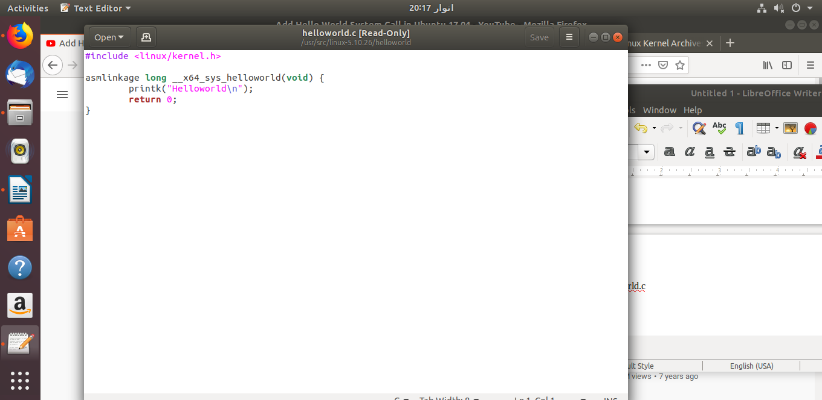
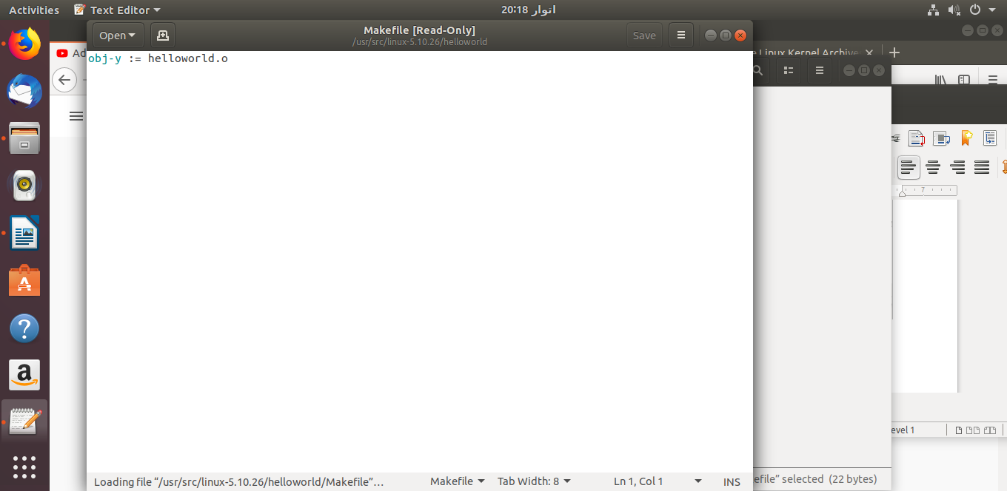
- gedit Makefile
- cd ..gedit Makefile
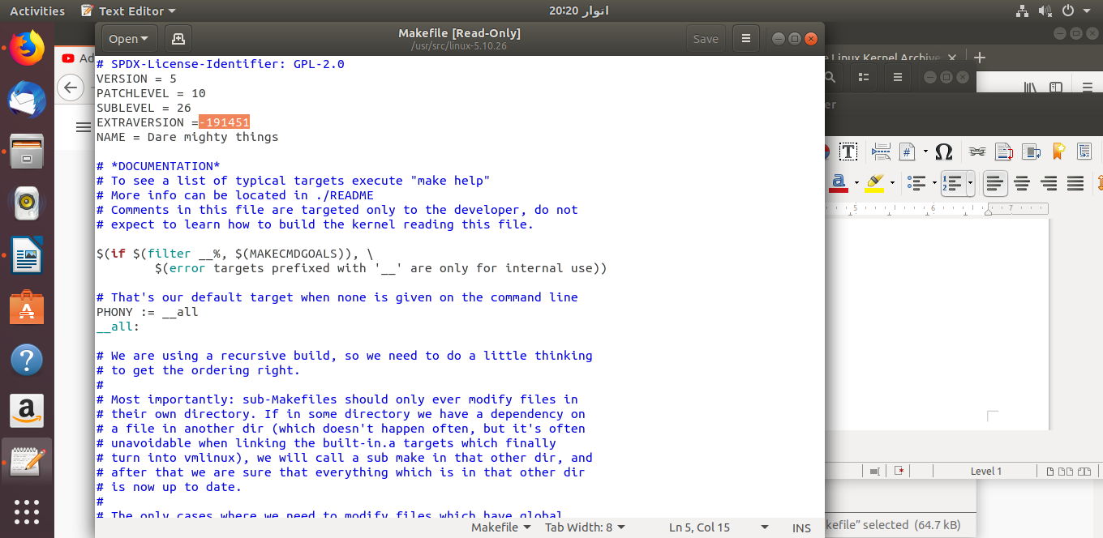
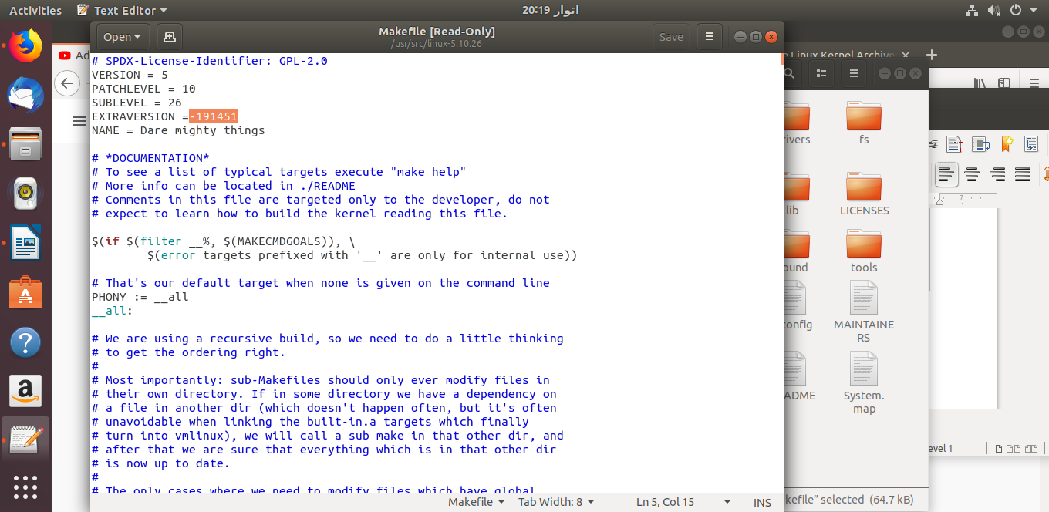
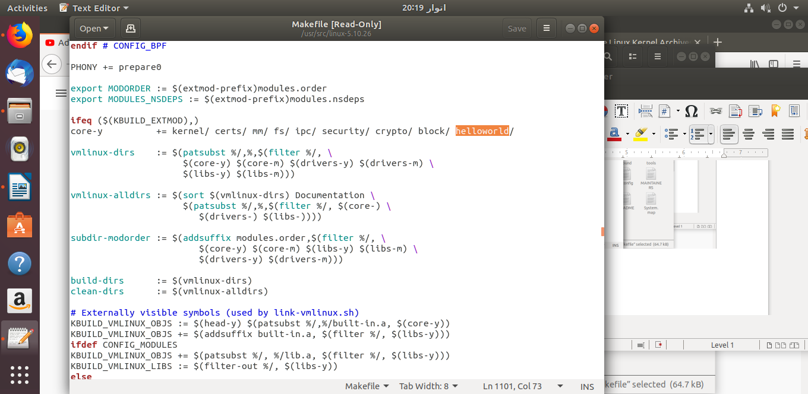
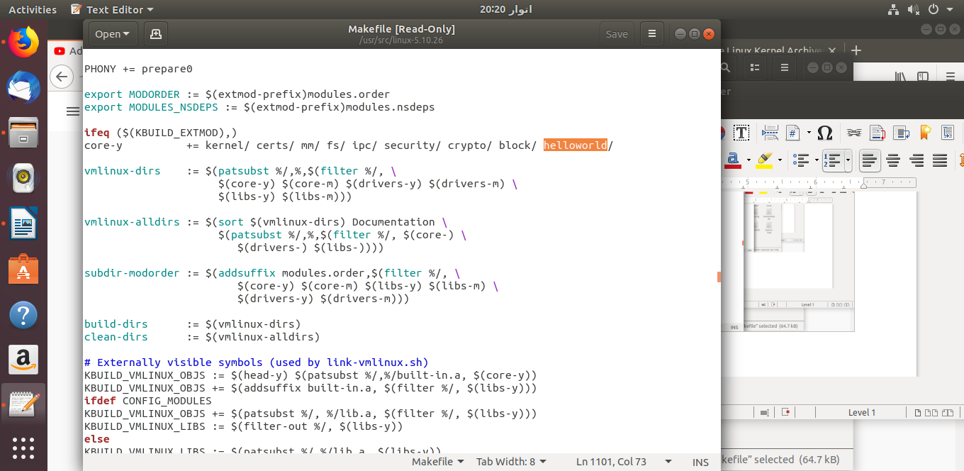
- cd include/linux
- gedit syscalls.h
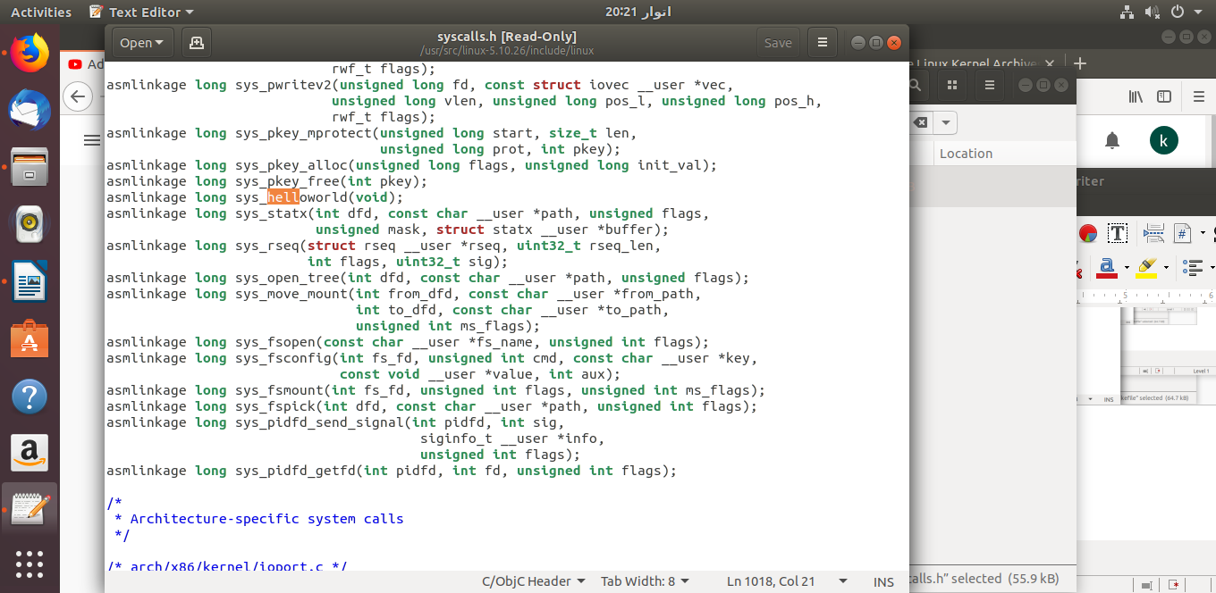
- cd /usr/src/linux-5.10.26/arch/x86/entry/syscalls
- gedit syscall_64.tbl
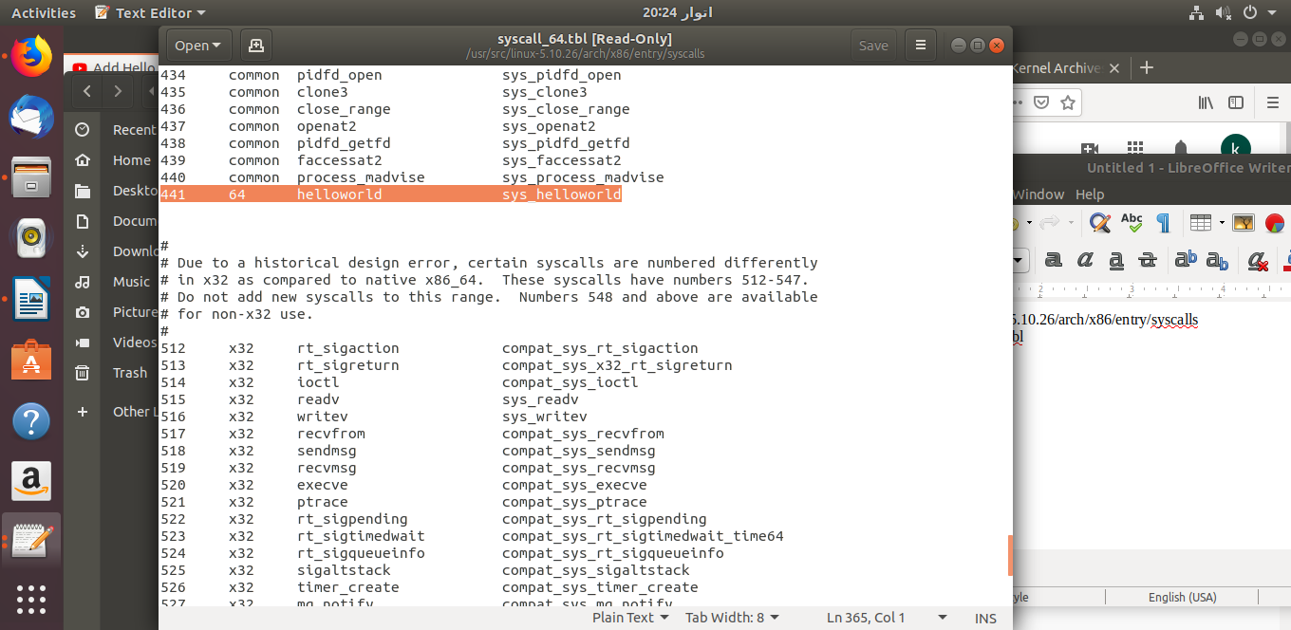
- cd ../../../..make menuconfig
- //Follow menuconfig from video tutorial
- make oldconfig
- sed -ri '/CONFIG_SYSTEM_TRUSTED_KEYS/s/=.+/=""/g' .config
- make -j4
- make modules_install install -j4
- //power off computer and start it. Hold shift to enter grub menu.Go to advanced options for ubuntu. There you will find your version(5.10.26 is mine) and hit enter.
- // Shown you output above. Thanks

